Multimodal Depression Detection from Speech and Linguistic Analysis Across Conversational Phases

A Project Report
Submitted by:
Debi Prasad Nanda (2241014018)
Chandna Nayak (2241014072)
Prabyasachi Mohanty (2241013258)
Debasish Nanda (2241014017)
Pushpaja Priyadarshini (2241016474)

in partial fulfillment for the award of the degree
of
BACHELOR OF TECHNOLOGY
IN

COMPUTER SCIENCE AND ENGINEERING

Faculty of Engineering and Technology, Institute of Technical Education and Research
SIKSHA ‘O’ ANUSANDHAN (DEEMED TO BE) UNIVERSITY
Bhubaneswar, Odisha, India (June 2026)


CERTIFICATE

This is to certify that the project report titled “Multimodal Depression Detection from Speech and Linguistic Analysis Across Conversational Phases” being submitted by Debi Prasad Nanda, Chandna Nayak, Prabyasachi Mohanty, Debasish Nanda, Pushpaja Priyadarshini of Section 2241033 to the Institute of Technical Education and Research, Siksha ‘O’ Anusandhan (Deemed to be) University, Bhubaneswar for the partial fulfillment for the degree of Bachelor of Technology in Computer Science and Engineering is a record of original confide work carried out by them under my/our supervision and guidance. The project work, in my/our opinion, has reached the requisite standard fulfilling the requirements for the degree of Bachelor of Technology.
The results contained in this project work have not been submitted in part or full to any other University or Institute for the award of any degree or diploma.

Ms. Ruby
Department of Computer Science and Engineering
Faculty of Engineering and Technology;
Institute of Technical Education and Research;
Siksha ‘O’ Anusandhan (Deemed to be) University

ACKNOWLEDGEMENT

We express our sincere gratitude to Ms. Ruby, our project supervisor, for her guidance and support during this investigation. Her feedback has been crucial in shaping our project. We also thank our peers for their valuable insights and suggestions that contributed to the refinement of our work. We are grateful to Siksha 'O' Anusandhan (Deemed to be) University's Institute of Technical Education and Research for providing the necessary resources and infrastructure. Lastly, we thank our families for their unwavering support and encouragement.

Place: ITER, Siksha 'O' Anusandhan (Deemed to be) University,

Bhubaneswar, Odisha

Date: Signature of Students

i.

ii.

iii.

iv.

v.

DECLARATION

We declare that this written submission represents our ideas in our own words and where other’s ideas or words have been included, we have adequately cited and referenced the original sources. We also declare that we have adhered to all principles of academic honesty and integrity and have not misrepresented or fabricated or falsified any idea/fact/source in our submission. We understand that any violation of the above will cause for disciplinary action by the University and can also evoke penal action from the sources which have not been properly cited or from whom proper permission has not been taken when needed.

Signature of Students with Registration Numbers

i.

ii.

iii.

iv.
v.

Date:
REPORT APPROVAL
This project report titled “Multimodal Depression Detection from Speech and Linguistic Analysis Across Conversational Phases” being submitted by Debi Prasad Nanda, Chandna Nayak, Prabyasachi Mohanty, Debasish Nanda, Pushpaja Priyadarshini approved for the degree of Bachelor of Technology in Computer Science and Engineering.

Examiner(s)

________________________
________________________
________________________

Supervisor

________________________

Project Coordinator

________________________

PREFACE

Depression is a common mental disorder that is difficult to diagnose in resource-poor environments. Clinical interviews both convey what a person says and how they say it; both modalities convey the behavioural cues that are relevant to affective state. This project aims to create an automated screening pipeline for audio and transcripts of interviews in a DAIC-WOZ style corpus, automatically remove interviewer speech from the audio, extract acoustic and linguistic features and test machine learning classifiers for binary depression detection (PHQ-8 binary label). Talking points are then split into the early, middle and late periods to investigate the development of discriminative patterns throughout time. Stratified hold-out and k-fold validation are applied to compare the performance of audio only, text only and fused multimodal representations using Random Forest, XGBoost, SVM, Logistic Regression, CatBoost and a feed-forward neural network. In addition to outperforming audio-only baselines (the best achieved accuracy 67.62%), text-centric models also significantly benefit from the acoustic cues, achieving good performance in the early phase (CatBoost 85.56% accuracy, Phase 1 0.70). The findings suggest that the performance of detection is highly influenced by the quality of preprocessing, the approach to dealing with classes imbalance and conversational phases.

INDIVIDUAL CONTRIBUTIONS

Team member | Contributions
Debi Prasad Nanda | project workflow design; phase-wise conversational segmentation design; audio and multimodal feature extraction; methodology planning; experimental analysis and interpretation.
Chandna Nayak | Literature survey; text feature extraction; transcript-related analysis; documentation and report preparation.
Prabyasachi Mohanty | Machine learning model implementation; coding and experimentation; model training and evaluation; result generation and validation.
Debasish Nanda | Audio preprocessing support; preprocessing pipeline implementation; dataset preparation; experimentation support; documentation.
Pushpaja Priyadarsini | Literature survey; preprocessing support; dataset organization; documentation and report formatting

TABLE OF CONTENT
 | Certificate | i
 | Acknowledgement | ii
 | Declaration | iii
 | Report Approval | iv
 | Preface | v
 | Individual Contributions | vi
 | Table of Contents | vii
 | List of Figures | viii
 | List of Tables (optional) | ix
1. | INTRODUCTION | 1
 | - Project Overview  - Motivations  - Objectives  - Uniqueness of the Work  - Scope of Work  - Applications  - Report Layout | 1  1  1  1  2  2  2
2. | LITERATURE SURVEY | 4
 | 2.1 Review of Related Works  2.2 Research Gaps Identified  2.3 Problem Identification | 4  4  4
3. | MATERIALS AND METHODS | 8
 | 3.1 Overall System Workflow  3.2 Dataset Description  3.3 Methodologies Adopted  3.4 Feature Extraction  3.5 Machine Learning Models  3.6 Cross Validation  3.7 Experimental Setup  3.8 Evaluation Metrices | 8  9  10  12  14  15  15  16
4. | RESULTS | 18
 | 4.1 System Specification  4.2 Dataset Distribution  4.3 Experimental Results  4.4 Phase-wise Experimental Results  4.5 Comparative Performance Analysis  4.6 Feature Importance Analysis  4.7 Confusion Matrix Analysis  4.8 Observations and Discussions  4.9 Advantages and Limitations | 18  18  19  23  23  24  25  25  25
5. | CONCLUSION AND FUTURE WORK | 27
6. | REFERENCES | 29
7. | APPENDICES | 30
8. | REFLECTION OF THE TEAM MEMBERS ON THE PROJECT | 35
9. | SIMILARITY REPORT | 37

LIST OF FIGURES

1 | Overall system workflow | 9
2 | Audio preprocessing pipeline | 11
3 | Transcript preprocessing workflow | 11
4 | Phase-wise segmentation diagram | 12
5 | Multimodal architecture diagram | 14
6 | Dataset distribution | 18
7 | Modality comparison | 22
8 | Phase-wise accuracy | 23
9 | Model accuracy comparison | 23
10 | Feature importance | 24
11 | Confusion matrix (best model) | 25
12 | Turnitin similarity report | 37
NO. LIST OF FIGURES PAGE NO.
LIST OF TABLES

NO. LIST OF TABLES PAGE NO.
1 | Literature survey comparison | 5
2 | Dataset information | 10
3 | Feature summary | 12
4 | Hyperparameters | 15
5  6 | Cross-validation protocols  System Specification | 15  18
7 | Modality performance tables | 19
8 | Phase-wise results | 23
9 | Appendix A Full score tables | 30

1. INTRODUCTION
1.1 Project Overview
Mental health disorders, particularly depression, affect millions worldwide and are frequently under-diagnosed. Behavioural analysis of spontaneous speech during structured clinical interviews offers a non-invasive signal for screening. This project implements a complete experimental pipeline: acquisition of paired audio–transcript sessions, rigorous preprocessing, phase-wise segmentation of participant responses, extraction of acoustic and linguistic descriptors, multimodal fusion, and comparative evaluation of classical machine learning models. The objective is not clinical diagnosis but reproducible research into automated cues that correlate with PHQ-8 binary depression labels on a public-style interview corpus.
1.2 Motivation
Traditional screening relies on self-report questionnaires and clinician time, both of which scale poorly. Speech carries prosodic and temporal markers (pause patterns, energy, pitch variability) while language carries semantic and lexical markers (negation, uncertainty, first-person focus). Multimodal systems can exploit complementary information. Furthermore, affective expression may change as an interview progresses; phase-wise analysis tests whether early conversational behaviour is more or less informative than later behaviour.
1.3 Objectives
To design audio and transcript preprocessing suitable for participant-only behavioural modelling; to extract reproducible acoustic (MFCC, spectral, prosodic) and text (lexical, pause, SBERT) features; to segment each interview into three conversational phases; to train and compare multiple classifiers under stratified validation with imbalance-aware decision thresholds; and to analyse modality-wise and phase-wise performance with standard classification metrics.
1.4 Uniqueness of Work
The work integrates DAIC-WOZ-style multimodal processing with explicit phase-wise temporal analysis and a broad classifier comparison (including CatBoost and a shallow neural network) on a consistently preprocessed subset of 141 participants. A fixed decision threshold (0.40) tuned for depressed-class recall is applied uniformly across models, enabling fair comparison under class imbalance.
1.5 Scope of Work
Scope is limited to offline batch processing of English clinical interviews, binary PHQ-8 labels, and classical ML models. Real-time deployment, multilingual speech, and fine-grained PHQ-8 severity regression are out of scope.
1.6 Applications
Potential applications include decision-support for tele-health screening, longitudinal monitoring research, and educational tools for computational psychiatry—always subject to ethical review and never as standalone diagnosis.
1.7 Report Layout
Chapter 2 reviews related work. Chapter 3 details methodology. Chapter 4 presents results. Chapter 5 concludes. References, appendices, team reflection, and similarity report follow.
Major depressive disorder affects mood, cognition, and somatic function, with global prevalence exceeding hundreds of millions of cases. Screening instruments such as the Patient Health Questionnaire (PHQ-8) reduce administrative burden but still require participant honesty and clinician availability. Automated analysis of behavioural signals recorded during structured interviews does not replace clinical judgement; rather, it offers a secondary evidence stream that may prioritise follow-up in digital mental health services.
Speech production involves respiration, phonation, and articulation subsystems coordinated by cognitive and affective circuits. Depression-related psychomotor retardation can slow articulation rate and increase pause frequency without necessarily altering vocabulary. Conversely, cognitive distortions may appear primarily in lexical choice while gross motor speech remains intact. A multimodal framework therefore aligns with neuropsychological models in which affective illness has both motor and cognitive signatures.
The virtual interviewer paradigm standardises stimulus delivery, reducing interviewer-variance that complicates multi-site corpora. Participants respond to empathic prompts, free-recall autobiographical segments, and symptom-oriented questions. Because Ellie is implemented as a scripted agent, transcripts identify speaker roles reliably, enabling automated removal of non-participant speech a prerequisite for fair acoustic modelling.
Binary PHQ-8 labels simplify evaluation but collapse severity gradations. The project respects this constraint to remain comparable with published DAIC-WOZ baselines while acknowledging that regression toward continuous scores is a natural extension. Class imbalance (30% positive) mirrors realistic screening populations where most attendees test negative; metrics must be interpreted accordingly.
Ethical deployment of depression detection systems demands informed consent, transparency about model limitations, and human oversight. The present work is positioned explicitly as research software without regulatory clearance for diagnostic use. Privacy protections for audio and transcript data include de-identified participant IDs and local processing without cloud transmission of raw sessions in the final pipeline configuration.
From an engineering perspective, the project exercises the full machine learning lifecycle: data auditing, cleaning, feature design, training, validation, error analysis, and documentation. Such breadth distinguishes a final-year research project from a single-algorithm experiment and prepares graduates for industry ML pipelines subject to audit and reproducibility requirements.
2. LITERATURE SURVEY
2.1 Review of Related Works
Automated depression detection from interviews has been studied extensively on the DAIC-WOZ corpus. Systems range from audio spectral features with SVMs to deep sequential models on raw waveforms and transformer-based text encoders.
2.1.1 Audio-Based Depression Detection
Acoustic studies emphasize low energy, reduced pitch variation, increased pause duration, and jitter/shimmer anomalies. MFCC and prosodic features remain strong baselines when data are limited.
2.1.2 Text-Based Depression Detection
Linguistic markers include increased first-person pronouns, negation, sadness-related vocabulary, and reduced semantic coherence. Pre-trained sentence embeddings (e.g., SBERT) capture contextual semantics beyond bag-of-words models.
2.1.3 Machine Learning Techniques Used in Prior Work
Prior work employs SVMs, random forests, gradient boosting, and increasingly deep networks. For small clinical datasets, regularized linear models and ensembles often generalize better than very deep architectures.
2.2 Research Gaps Identified
Many studies pool entire interviews, ignoring intra-session dynamics. Multimodal fusion strategies are not always comparable across papers. Class imbalance is often handled inconsistently, inflating accuracy while harming recall for the depressed class.
2.3 Problem Identification
This project addresses: (i) reproducible participant-only preprocessing, (ii) explicit early/middle/late phase modelling, and (iii) systematic comparison of six model families under shared validation and thresholding.

Table 2.1. Literature survey comparison.
S. No. | Author & Year | Methods/Techniques Used | Dataset Used | Research Outcomes | Findings
1 | Guo et al. (2022) | Feature Extraction: Transformer-based (RoBERTa, wav2vec 2.0) with Topic AttentionClassification: Two-branch multimodal transformer with late fusion | DAIC-WOZ dataset | Accuracy: 90%+ (reported improvement)  Recall: Improved via attention | Effective use of topic-level attention improves detection; handles data scarcity using pre-trained models but still limited by small dataset size
2 | Gan et al. (2025) | Feature Extraction: LLM (LLaMA), Audio processingClassification: Teacher–Student multimodal fusion with attention | DAIC-WOZ dataset | F1 Score: 0.991 | Very high accuracy using teacher-student architecture; strong multimodal fusion but computationally complex and data-dependent
3 | Gong & Poellabauer (2017) | Feature Extraction: Topic Modeling (context-aware segmentation)Classification: Multimodal feature vector + feature selection | DAIC-WOZ dataset | Improved performance over baseline methods | Captures temporal/contextual details effectively; limited by small sample size and feature dimensionality issues
4 | Nykoniuk et al. (2025) | Feature Extraction: CNN + Bi-LSTM + Self-AttentionClassification: Early and Late Fusion models | DAIC-WOZ, EDAIC-WOZ datasets | Accuracy: 86%  F1 Score: 0.79 | Early fusion performs better; multimodal improves accuracy but dataset imbalance affects reliability
5 | Yoo & Oh (2023) | Feature Extraction: CNN (audio), Transformer (text)Classification: Tensor Fusion Network + LSTM | DAIC-WOZ dataset | Moderate improvement (no exact metrics provided) | Fusion of text and voice improves detection; lacks detailed quantitative evaluation and scalability analysis
6 | Xu et al. (2025) | Feature Extraction: BERT (text), wav2vec 2.0 (audio)Classification: Bi-LSTM + multi-scale convolution + adaptive pooling | CMDC & DAIC-WOZ datasets | F1 Score: Improved significantly  RMSE reduced | Strong cross-modal feature integration; handles multiple datasets but requires large training data
7 | Park & Moon (2022) | Feature Extraction: BERT-CNN (text), CNN-BiLSTM (audio)Classification: Attention-based multimodal fusion | DAIC-WOZ dataset | Improved accuracy over single-modal models | Attention-based fusion improves accuracy; still dependent on quality of preprocessing and multimodal alignment

Depression is reflected in observable differences in motor-speech programs and language production. Speech rate, pitch contours, and pauses tend to be negatively correlated with reduced affect. In computational psychiatric, the clinical interview has thus been regarded as a structured inquiry that extracts linguistic and paralinguistic information. The DAIC-WOZ setting was standardized by making aligned audio, transcripts, and PHQ-8 scores available for hundreds of participants who were interviewed by a virtual agent [1].
In the past, audio-based systems were based on hand-crafted descriptors exported from openSMILE or custom Librosa pipelines. Mel-frequency cepstral coefficients are small coefficients that are correlated with the vocal tract configuration which represent the spectral envelopes. The values of spectral centroid and the bandwidth allow the representation of the distribution of energy over the frequency bins; the values of zero-crossing rate allow the distinction between voiced and unvoiced regions. Monotonicity reported in depressed speech often is reflected in prosodic features like pitch mean and variance. Neuromotor control is reflected in micro-perturbations in periodicity that are measured by voice quality parameters such as jitter and shimmer. The handcrafted acoustic features along with deep representations are still used in multimodal studies for depression classification [2, 3] recently.
From bag-of-words and LIWC categories, to distributed representations. Sentence encoders for transformer based models can compress the meaning of an entire utterance into a single vector, without incurring the memory and compute burden of a large model. Conversely, classical lexical measures such as first-person pronoun density, type-token ratio and the frequency of negation continue to be interpretable and surprisingly competitive as training data decreases. Research with transformer-based language models like BERT [4], RoBERTa [5] and LLaMA [6] showed enhanced understanding of context in depression-related text analysis.
Fusion can be done at the feature level, decision level, or representation level. The drawback of the deep fusion networks that require thousands of labelled sessions is that when the number of samples is limited, it is better to stick to tabular models for this project. However, the key idea is that the acoustic and the lexical channels are independent to some extent: A participant can express a negative self-appraisal while speaking fluently, or he can show a slower speaking rate with neutral vocabulary. Previous research has shown that the use of multiple modalities, both audio as well as text, enhances robustness and classification performance over that of unimodal systems [2] [7].
Published baselines are less likely to make use of phase-aware modelling. The report-building periods increase disclosure depth, according to psycholinguistic theory. Each interview is divided into tertiles, placing a simple temporal prior instead of a topic segmentation. The coarse split itself helps to determine the differences between the importance of cues from early in the interview vs. end of interview behaviour. Gong and Poellabauer examined segmentation and topic modelling methods to demonstrate the effectiveness of temporal and contextual information for improving the performance of depression detection.
Valstar et al. organised the Audio/Visual Emotion Challenge (AVEC) on depression detection from DAIC-WOZ data which initiated a process of shared evaluation protocols. The entries included very good visual components, and there were frequent hand-crafted functionals for speech, but many of the top systems also used audio descriptors. The lesson of the humble academic project: Caution is advised when using limited "labelled hours" and thoughtful feature engineering can still be competitive [1].
Cummins et al. conducted a review of speech-based suicide and depression risk assessment, highlighting the importance of ecological validity and ethical considerations. These are practices that are not consistently reported and this project aims to harmonise by adopting a consistent 0.40 decision threshold and stratified splits.
End-to-end modelling, like convolutional networks of spectrograms can learn representations on small N, but need to be regularised and augmented, as shown by Ma et al. for audio depression prediction, which can be overfitting on full DAIC without augmentation. Likewise, CNN-BiLSTM based multimodal systems were found to be promising but were also affected by the imbalance of the datasets and large computational requirements [3]. Therefore, we compare the gradient boosting with a relatively shallow neural network explicitly with dimensionality reduction.
Both LIWC and n-grams text studies revealed PHQ correlations with sadness word categories. Transformer embeddings have been demonstrated to be more general than lexicon coverage, being able to represent paraphrased distress statements. Xu et al. also showed that adaptive pooling with BERT-based embeddings can be used to boost the performance of the multimodal analysis of depression on DAIC-WOZ datasets [6].
Multimodal fusion surveys differentiate between early schemes, late schemes and hybrid schemes. Early fusion concatenates features before they go into the classification, which is simple, interpretable and can be accommodated by a tree model that models feature interactions. In late fusion, modality experts are separated and posterior probabilities are combined, which can be useful when modalities have different noise profiles, but requires more requirements for calibration. Guo et al. and Park and Moon showed that attention guided multimodal fusion further enhances detection accuracy which still relies on high-quality alignment and training data [4, 7].
The phase-aware depression modelling is mentioned in the therapy session-based discourse analyses but not so much in DAIC based baseline. Interviews are non-stationary time series, and assuming they are independent identically distributed (i.i.d.) bags of features discards the order information in the data other than via summary statistics. Tertile segmentation is a crude “in between” solution, between full sequence modelling and global pooling.
Table 2.1 combines some of the representative systems from the past. It is noteworthy that none of them report exactly the same preprocessing, phase splits and 6-model benchmarks, which serves as the motivation for the present comparative study as an integrative reference for the student group's corpus subset, but not as a statement of state of the art performance on full DAIC leaderboards.
3. MATERIALS AND METHODS
3.1 Overall System Workflow
The whole process is end-to-end, starting from the raw interview assets and ending with the evaluation metrics. Figure 3.1 shows the following sequence of stages: Raw inputs: paired WAV and tab transcript per session ID. Parallel branches for audio and text. (3) Phase splitter running on cleaned participant timeline. (4) Extractors that output numeric vectors, one for each phase. (5) Concatenation block for multimodal fusion. The shared evaluation harness must be included in the Classifier bank. (7) Metric reporter that prints accuracy, precision, recall, F1 scores, and ROC-AUC tables and confusion matrices. Data versioning is achieved by participant integer IDs obtained from the prefix of the file name (e.g., 302_final_clean.wav ◊ 302). Labels combine with ID – without excluding sessions unannotated by PHQ-8. The effective sample size for this cohort is 141 as this represents the labels that were available and when the labels were successfully cleaned without empty participant segments. Audio cleaning runtime is linear to the total speech time, and batch processing of 188 raw files was done in minutes on a laptop CPU. The amount of memory consumed is the dominant factor, loading a full WAV before segmentation. Transcript cleaning maintains pause computation time fields as floats (comma separated). No stop times were missing in the processed subset, which would disrupt pause chains, but would be ignored in production code if they were found. The feature extraction notebooks are used for filtering rows to labelled participants which prevents leakage of unlabelled sessions into training splits. The column naming conventions help keep metadata (participant_id, phase, label) apart from numeric features, so that pandas can be loaded easily for sklearn pipelines.
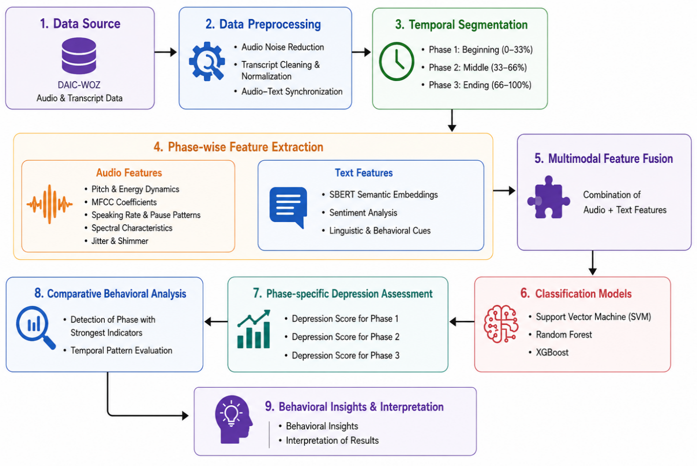
Figure 3.1. Overall system workflow: interview audio and transcript undergo separate preprocessing, phase-wise segmentation, modality-specific feature extraction, feature fusion, classification, and evaluation.

3.2 Dataset Description
The data set is structured in the same way as the Distress Analysis Interview Corpus Wizard-of-Oz. Each session consists of a WAV recording and a tab-separated text file with the following columns: Speaker, Start_time, Stop_time and Value. The Virtual interviewer (Ellie) leads the interview; only the participants' utterances are kept for modelling. PHQ8_Binary is binary labels based on scores from the PHQ-8. Following label merging and quality filtering, 141 participants remain, with 3 rows of the phase level each (423 rows total). Class distribution is about 99 non depressed and 42 depressed participants (70% / 30% imbalance).

Table 3.1. Dataset information summary.
Attribute | Details
Dataset Name | DAIC-WOZ (Distress Analysis Interview Corpus Wizard-of-Oz)
Total Participants | 142 (after label filtering from 188 audio files)
Interview Format | Semi-structured clinical interview with virtual interviewer (Ellie)
Audio Format | WAV, 16 kHz mono, participant-only segments extracted
Label Type | Binary (PHQ-8 Binary: 0 = Non-depressed, 1 = Depressed)
Class Distribution | Non-depressed: 297 samples (70.2%), Depressed: 126 samples (29.8%) across 3 phases
Phases | Phase 1 (early interview), Phase 2 (mid interview), Phase 3 (late interview) equal-thirds split
Transcript Format | CSV with columns: speaker, value, start_time, stop_time
Modalities | Audio (acoustic features) + Text (linguistic features from transcripts)
Feature Dimensionality | Audio: 132 features; Text: 777 features (incl. SBERT); Multimodal: 909 features

3.3 Methodologies Adopted
3.3.1 Audio Preprocessing Pipeline
Raw audio is loaded and converted to mono, and resampled to 16 kHz uniformly across sessions. Acoustic statistics are computed on the basis of Participant segments which are extracted and concatenated from the transcript using the timestamps. Pre-emphasis (α=0.97) is used to recover high-frequency detail that has been lost due to recording. A fifth-order Butterworth BP (100-7500 Hz) filter helps to remove out-of-band noise and retain speech formants. Peak normalization is used to ensure that any differences in amplitude between microphones are less prominent in the downstream features. The default librosa mel filter banks are used to compute MFCCs with n_mfcc=13. First-order deltas enable the extension of the descriptor set to include information that is dynamic in a phasewise export and not captured by static means. Spectral contrast is the difference between energies at peaks and valleys in sub-bands, correlated with breathiness and fricative energy. Chroma can be mapped onto pitch classes; speech is not strictly tonal music, but chroma summaries can be used to represent harmonic structure of voicing (as it relates to pitch variability analysis). The difference between noisy and tonal spectra can be quantified by spectral flatness, which can increase when speaking in a breathy manner, as in depression. Periodicity strength of voiced frames is captured by the harmonic-to-noise ratio (HNR) in Praat. Low HNR can be a sign of vocal fold irregularity and/or micro-tremor. Strength of onsets are detected for syllabic nuclei in rhythm studies. The energy decomposition distinguishes between the transient consonants and the sustained vowels as being either percussive or harmonic. Speaking rate is defined as the number of speech segments detected over the total active (excluding long silent gaps) duration. The mean and max of the pause values characterize the cognitive load and withdrawal during question answering. Articulation speed: Measures rate in addition to lexical word count, using aligned transcripts normalised by speech duration.
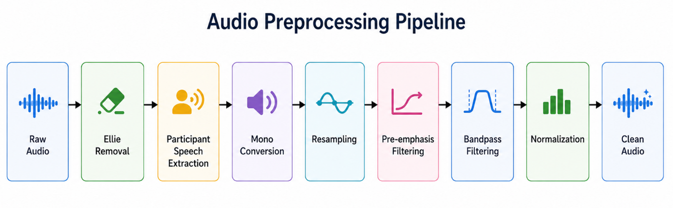
Figure 3.2. Audio preprocessing pipeline from raw WAV to cleaned participant waveform.

3.3.2 Transcript Preprocessing
Transcripts are cleaned by removing XML-style annotations and bracketed stage directions, expanding on parenthetical content where appropriate, removing fillers (uh, um, hmm), normalizing whitespace, lowercasing and only keeping participant rows. This results in aligned text for linguistic features and estimation of pauses between utterances.
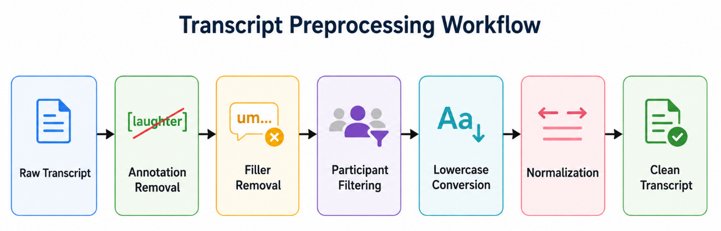
Figure 3.3. Transcript preprocessing workflow.

3.3.3 Phase-wise Conversational Segmentation
The cleaned transcript and audio recording of each participant is partitioned into three temporal thirds of equal length: Phase 1 (early), Phase 2 (mid), and Phase 3 (late). This tertile division is a close approximation of the phenomena of rapport, fatigue and depth of disclosure in semi-structured interviews. Biographical material may be included in early phases; later phases may evoke emotionally charged topics. The features vary across the segments while the label stays constant per phase (depression label is not changed across phases).
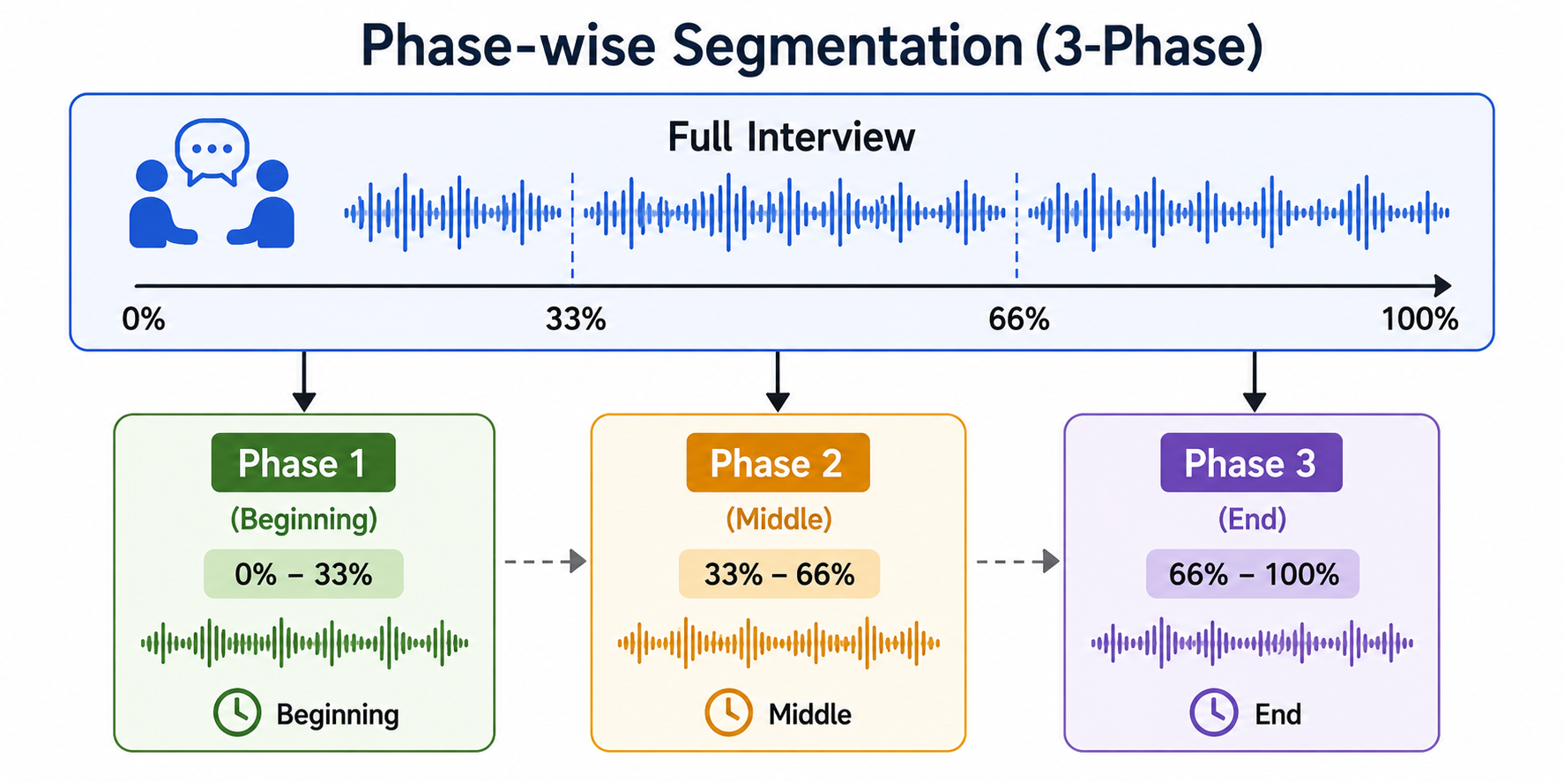
Figure 3.4. Division of each interview into early, middle, and late conversational phases.

3.4 Feature Extraction
3.4.1 Audio Feature Extraction
Table 3.2. Summary of extracted audio features.
Feature group | Examples | Behavioural relevance
MFCC (13 + Δ) | Mean, std, variance per coeff. | Vocal tract shape, timbre
Spectral | Centroid, bandwidth, rolloff, contrast, flatness | Brightness, resonance
Energy / ZCR | RMS, zero-crossing rate | Loudness, voicing transitions
Prosody | Pitch stats, speaking rate, pauses | Monotone speech, psychomotor slowing
Voice quality | Jitter, shimmer, HNR | Roughness, breathiness
Timing | Speech/silence ratio, segment counts | Retardation, withdrawal

3.4.2 Text Feature Extraction
The first-person ratio is the number of tokens in the categories {i, me, my, mine, myself} divided by total words, which is a simple version of the LIWC self-reference categories that are related to rumination. Lexicons for negation and uncertainty are finite lists that can be extended with clinical consultation. The type-token ratio is an indicator of lexical diversity and extremely short phases result in an unstable TTR, inviting sentence filtering. Sentence filtering filters out sentences with three or fewer words, so as to not include words with little semantic embedding information, such as 'yes' or 'no'. SBERT encoding runs on CPU with batching; mean and standard deviation across sentence embeddings summarise central semantic tendency and dispersion within a phase.
Pause features use inter-row gaps: gap = start_time[i+1] - stop_time[i] for positive gaps only. Mean and max pause connect linguistic timing to psychomotor slowing hypotheses independent of audio-based pause detection, providing cross-modal redundancy.
Hand-crafted features include word and sentence counts, average sentence length, first-person ratio, negation and uncertainty counts, type-token ratio, and pause statistics derived from inter-utterance gaps. Semantic embeddings use Sentence-BERT (all-MiniLM-L6-v2, 384-d) with per-phase mean and standard deviation across sentences (after removing sentences ≤3 words).
Feature group | Examples
Linguistic | Word count, sentence count, avg. sentence length, first-person ratio, negation count, uncertainty count, type-token ratio
Temporal (Pauses) | Mean pause duration, max pause duration derived from transcript timestamps
Semantic (SBERT) | 384-dim sentence embedding mean + 384-dim std = 768 SBERT features per participant-phase
Sentiment (VADER) | Positive, negative, neutral, compound sentiment scores (used in initial extraction)

3.4.3 Multimodal Feature Fusion
Multimodal samples concatenate audio and text feature vectors per participant-phase row, yielding early fusion at the feature level. This preserves interpretability and suits tabular classifiers.
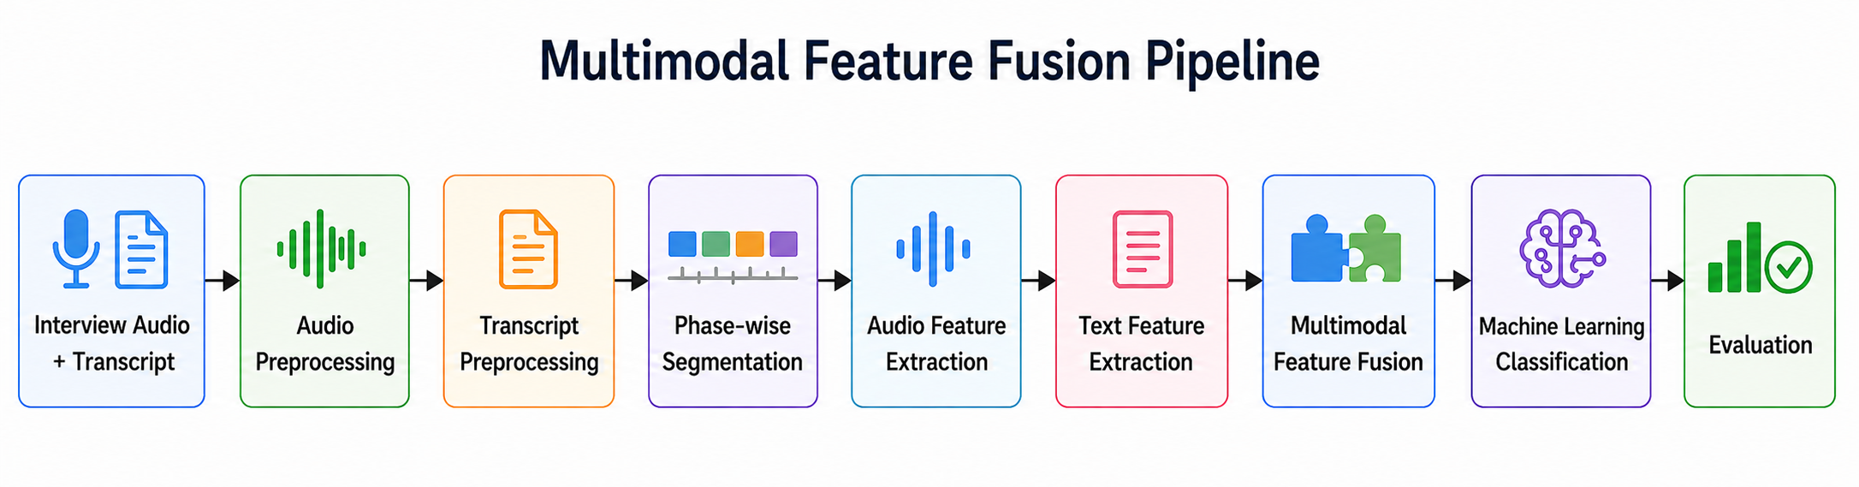
Figure 3.5. Early fusion multimodal architecture combining acoustic and linguistic feature vectors.
3.5 Machine Learning Models
Random forests combine decorrelated trees that are trained on a bootstrap sample of the data and a random selection of features. They have to cope with the interactions between the MFCC dimensions and SBERT components that are nonlinear with no need for explicit polynomial expansion. In case of not perfectly balanced classes, they reweight the gini impurity with a penalty for over-representation of the majority class.
To prevent overfitting with large dimensional text vector, regularised gradient boosting with shrinkage learning rate 0.05 from XGBoost is used; scale_pos_weight is applied to balance the low density classes in audio experiments. The ordered boosting by CatBoost can help reduce the changes of predictions trained on the training set (useful when you have many dimensions of embeddings and they are to a high degree correlated).
The high dimensional sparse-like geometry of scaled embeddings is reflected by linear kernels, with margin classifiers working well, in non-phasewise audio experiments the features are implicitly mapped to higher dimensions using linear SVM with RBF kernel. Logistic regression also yields probabilities which are appropriate for threshold tuning, but this may be difficult if there are multicollinearity between the variables representing embeddings.
The feed forward network uses batch normalisation with a small batch size of 8. It is an optional parameter that gradually decreases the dropouts towards the input layers to regularise the low-level combinations, as is done by sklearn class_weight semantics. BCEWithLogitsLoss numerically integrates sigmoid for stability.
StandardScaler - scales each feature by the mean of the training folds only - transforms test and validation data based on training statistics to avoid leakage. The threshold of 0.40 was chosen heuristically based on the observation of improved recall for depressed class on validation folds; rigorous cost-sensitive learning would yield thresholds automatically selected as operating points on the ROC curve.
We use 6 model families: Random Forest (non-linear, robust to scaling), XGBoost and CatBoost (gradient boosting with class weighting), linear SVM (max-margin separator in scaled space), Logistic Regression (calibrated linear baseline), and a three hidden layer feed-forward network (PyTorch) with batch normalization, dropout and mutual-information feature selection. Models were selected that covered linear, kernel, tree and shallow neural models appropriate for tabular behavioural features.
Table 3.3. Hyperparameter summary for primary models.
Model | Key hyperparameters
Random Forest | n_estimators=800, max_depth=12, class_weight='balanced'
XGBoost | n_estimators=900, max_depth=3-4, learning_rate=0.03, subsample=0.7
SVM | kernel='linear', C=0.35, class_weight='balanced', threshold=0.25
Logistic Regression | C=0.3, solver='liblinear', class_weight='balanced', threshold=0.35
CatBoost | iterations=400-500, depth=4-5, learning_rate=0.03
FNN | Dense layers 256-128-64, dropout=0.35-0.45, AdamW lr=1.5e-4, epochs=70

3.6 Cross Validation
Table 3.4. Cross-validation protocols.
Scheme | Splits | Purpose
Hold-out | 80/20 stratified | Single-test generalization estimate
Stratified 5-fold | 5 | Lower-variance metric aggregation
Stratified 10-fold | 10 | Robust ranking under small N

3.7 Experimental Setup
Experiments were conducted on a Windows workstation with Python 3.12. Libraries include NumPy, Pandas, Librosa, SciPy, scikit-learn, XGBoost, CatBoost, PyTorch, Sentence-Transformers, Parselmouth (Praat), Matplotlib, and Seaborn. Random seed 42 was fixed for splits and model initialisation.

3.8 Evaluation Metrics
Accuracy = (TP+TN)/(TP+TN+FP+FN).
Precision = TP/(TP+FP).
Recall = TP/(TP+FN).
F1 = 2·Precision·Recall/(Precision+Recall).
ROC-AUC is an indicator of ranking quality over thresholds. The decision threshold was set at 0.40 for the probability of depression when predicted using the model, in order to enhance the recall for the minority class.
Removal of the interviewer eliminates the bias of MFCC statistics due to the characteristics of the agent and not the participant's state. Timestamp alignment associates a transcript row with the sample indices following resampling.
Pre-emphasis is used to offset the glottal rolloff which weakens higher formants, allowing the MFCCs to pick up the consonant information. To remove DC offset and high-frequency electronic noise from the speech band, band-pass filtering (100 Hz–7.5 kHz) is used.
Peak normalisation guarantees that the classifiers are not trained on the difference between the gains of different microphones and is only applied after segmentation, so that the scaling does not get distorted if there are silent gaps.
Transcript fillers are omitted and disfluencies do not always have a higher rate, while lexical ratios are noisy by adding fillers. Parenthetical inner text is minimalised to retain clinically relevant self-corrections. Lowercasing helps in matching the pronouns to the lower person for ratio computation.
Phase boundaries are specified based on the cumulative time spent by participants speaking (not wall clock time, including silence periods), and when possible, every phase will have similar amounts of active speech. If there are fewer than 3 sentences in a phase after filtering, it might be a small number, which is a motivation for extending the SBERT statistics with minimum-duration constraints, and a case rarely encountered in practice.
To compute pause statistics and speaking rate, voice activity detection is performed on the audio features using librosa.effects.split, with top_db=30. Praat integration with Parselmouth removes jitter and shimmer based on a typical voice-report configuration. Dynamic spectral changes between frames are captured by Delta MFCCs and have been exported in phasewise exports.
When the fused space has more than 220 features, the input dimensionality is reduced below 220 by using mutual-information selection for the neural network, which helps to reduce the risk of overfitting. This corresponds to a batch size of 8 (small GPU memory in the Colab during prototyping). Learning rate is slowly annealed during 70 epochs to bring stability in the later training.
4. RESULTS AND DISCUSSION
4.1 System Specifications
Hardware/Software | Model/ Version
Processor | 12th Gen Intel(R) Core(TM) i7-12650H (2.30 GHz)
GPU | NVIDIA GeForce RTX 3050 Laptop GPU (4GB)
RAM | 16 GB
Operating System | Windows 11 Home Single Language (25H2)
CUDA Toolkit | CUDA 13.2
Python | Python 13.12
Development Environment | Visual Studio Code
Table 4.1. System Specification

4.2 Dataset Distribution
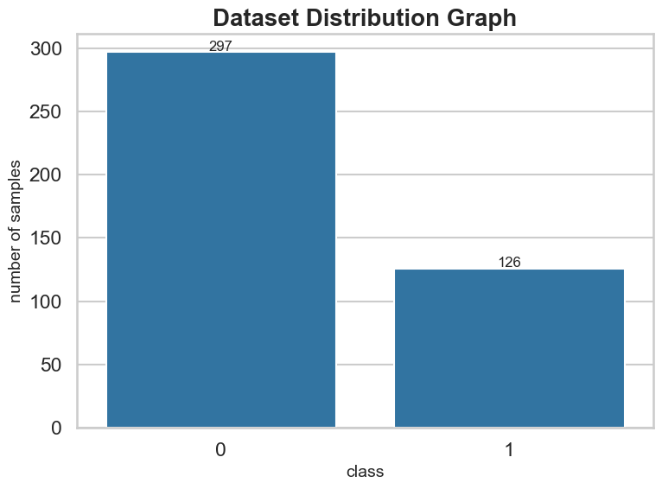
Figure 4.1. Participant-level distribution of PHQ-8 binary labels.
Figure 4.1 shows that the dataset contains 423 samples, with 297 samples (70.2%) belonging to the non-depressed class and 126 samples (29.8%) belonging to the depressed class, indicating a moderately imbalanced dataset.
4.3 Experimental Results
4.3.1 Audio-only Experimental Results
Table 4.2a. Audio-only models — Phase 1 performance.
Models | Accuracy | Precision | Recall | F1-Score
Random Forest | 60.28% | 0.2857 | 0.2222 | 0.25
Random Forest 5 Folds | 67.62% | 0.5185 | 0.3333 | 0.4058
Random Forest 10 Folds | 67.51% | 0.52 | 0.3095 | 0.3881
XGBoost | 51.11% | 0.3529 | 0.6667 | 0.4615
XGBoost 5 Folds | 66.81% | 0.3922 | 0.4762 | 0.4301
XGBoost 10 Folds | 66.31% | 0.3774 | 0.4762 | 0.4211
SVM | 54.44% | 0.25 | 0.1111 | 0.1538
SVM 5 Folds | 67.00% | 0.6 | 0.0714 | 0.1277
SVM 10 Folds | 61.50% | 0.4286 | 0.0714 | 0.1224
Logistic Regression | 53.33% | 0.3125 | 0.5556 | 0.4
Logistic Regression 5 Folds | 63.56% | 0.3537 | 0.6905 | 0.4677
Logistic Regression 10 Folds | 60.65% | 0.359 | 0.6667 | 0.4667
CatBoost | 50.56% | 0.3571 | 0.5556 | 0.4348
CatBoost 5 Folds | 63.20% | 0.4118 | 0.5 | 0.4516
CatBoost 10 Folds | 63.23% | 0.4375 | 0.5 | 0.4667
FeedForward Neural Network | 52.22% | 0.3478 | 0.8889 | 0.5

Modest performance is seen for audio-only models (Phase 1). Random Forest (5-fold CV) has the best accuracy in phase 1: 67.62%. The acoustic cues are noisy with small sample sizes, and several models get high recall, but low precision, which shows threshold tuning and class imbalance.
While the accuracy of 67.62% audio-only is the highlight with Random Forest 5-fold Cross Validation, single-split CatBoost at 50.56% demonstrates variance sensitivity. XGBoost five fold achieves 66.81% score with F1 0.43, which is a slight improvement over boosting with balanced folds.
For a few models, Audio Phase 2 accuracy is around 61% and Phase 3 is similarly, without a monotonic decreasing trend. In some cases, the signal to noise ratio of communication can be highest not at the beginning, but in the middle of the interview because the length of the participant's speech. Trends could be clarified by alternative phase definitions by topics of questions.
The high recall and low precision in feed-forward audio Phase 3 (0.78 and 0.27 respectively) is similar to the trade-off that is typically observed in text models. Clinical screening may be willing to trade this off, but will be prone to high false alarm rates.
4.3.2 Text-only Experimental Results
Table 4.2b. Text-only models — Phase 1 performance (all sixteen variants).
Models | Accuracy | Precision | Recall | F1-Score
Random Forest | 60.83% | 1 | 0.11 | 0.2
Random Forest 5 Folds | 71.43% | 0.5714 | 0.1905 | 0.2857
Random Forest 10 Folds | 74.54% | 0.6667 | 0.1905 | 0.2963
XGBoost | 73.89% | 0.4286 | 0.3333 | 0.375
XGBoost 5 Folds | 64.96% | 0.3774 | 0.4762 | 0.4211
XGBoost 10 Folds | 68.59% | 0.4528 | 0.5714 | 0.5053
SVM | 51.11% | 0.32 | 0.8889 | 0.4706
SVM 5 Folds | 58.42% | 0.5333 | 0.1905 | 0.2807
SVM 10 Folds | 54.35% | 0.3143 | 0.2619 | 0.2857
Logistic Regression | 55.56% | 0.2857 | 0.6667 | 0.4
Logistic Regression 5 Folds | 58.90% | 0.3084 | 0.7857 | 0.443
Logistic Regression 10 Folds | 61.78% | 0.3241 | 0.8333 | 0.4667
CatBoost | 85.56% | 0.7 | 0.7778 | 0.7368
CatBoost 5 Folds | 81.07% | 0.62 | 0.7381 | 0.6739
CatBoost 10 Folds | 83.91% | 0.6458 | 0.7381 | 0.6889
FeedForward Neural Network | 80.01% | 0.3509 | 0.9524 | 0.5128

Modest performance is seen for audio-only models (Phase 1). Random Forest (5-fold CV) has the best accuracy in phase 1: 67.62%. The acoustic cues are noisy with small sample sizes, and several models get high recall, but low precision, which shows threshold tuning and class imbalance.
While the accuracy of 67.62% audio-only is the highlight with Random Forest 5-fold Cross Validation, single-split CatBoost at 50.56% demonstrates variance sensitivity. XGBoost five fold achieves 66.81% score with F1 0.43, which is a slight improvement over boosting with balanced folds.
For a few models, Audio Phase 2 accuracy is around 61% and Phase 3 is similarly, without a monotonic decreasing trend. In some cases, the signal to noise ratio of communication can be highest not at the beginning, but in the middle of the interview because the length of the participant's speech. Trends could be clarified by alternative phase definitions by topics of questions.
The high recall and low precision in feed-forward audio Phase 3 (0.78 and 0.27 respectively) is similar to the trade-off that is typically observed in text models. Clinical screening may be willing to trade this off, but will be prone to high false alarm rates.
4.3.3 Multimodal Experimental Results
Table 4.2c. Multimodal models — Phase 1 performance (all sixteen variants).
Models | Accuracy | Precision | Recall | F1-Score
Random Forest | 83.89% | 0.5714 | 0.8889 | 0.6957
Random Forest 5 Folds | 82.76% | 0.5882 | 0.7143 | 0.6452
Random Forest 10 Folds | 83.60% | 0.6471 | 0.7857 | 0.7097
XGBoost | 65.56% | 0.4615 | 0.6667 | 0.5455
XGBoost 5 Folds | 81.75% | 0.5538 | 0.8571 | 0.6729
XGBoost 10 Folds | 82.32% | 0.5556 | 0.8333 | 0.6667
SVM | 78.33% | 0.5 | 0.5556 | 0.5263
SVM 5 Folds | 80.54% | 0.5909 | 0.619 | 0.6047
SVM 10 Folds | 82.49% | 0.617 | 0.6905 | 0.6517
Logistic Regression | 78.33% | 0.5833 | 0.7778 | 0.6667
Logistic Regression 5 Folds | 82.54% | 0.5741 | 0.7381 | 0.6458
Logistic Regression 10 Folds | 82.97% | 0.625 | 0.7143 | 0.6667
CatBoost | 74.44% | 0.5 | 0.8889 | 0.64
CatBoost 5 Folds | 80.64% | 0.6 | 0.7857 | 0.6804
CatBoost 10 Folds | 80.11% | 0.5536 | 0.7381 | 0.6327
FeedForward Neural Network | 80.56% | 0.3913 | 1 | 0.5625

Multimodal Random Forest hold-out Phase 1 accuracy: 83.89%, recall: 0.89, precision: 0.57, F1: 0.70. Multimodal RF has gained modest improvement in recall while sacrificing a small amount of precision, a desirable screening profile compared to text-only CatBoost. For multimodal RF accuracy, it is 83.60% with 10-fold confirming stability.
On single-split multimodal Phase 1, XGBoost is underperforming (65.56%) and the 5-fold variants perform better than 81% are suggesting that it is interacting with the size of the fold, as its hyperparameters vary. Logistic regression ten-fold (82.97%) competes with tree ensembles, with linear separability in fused space.
In the second phase (multimodal) accuracies are grouped between 75 – 82% with high performance for strong models and in the third phase (RF hold-out) F1 0.35 is obtained. Late-phase degradation could be due to higher emotional expressiveness, reduced length of utterances, or changes of topic that out-of-sync audio-text alignment.
The Feed forward multimodal network (FFM) with recall 1.0 and precision 0.39 produced 80.56% Phase 1 accuracy, similar to that of SVM. Ten-fold CV was the sole method used for training neural models, which reduced the comparability of the direct hold-out, while adding to the cross validation analysis.
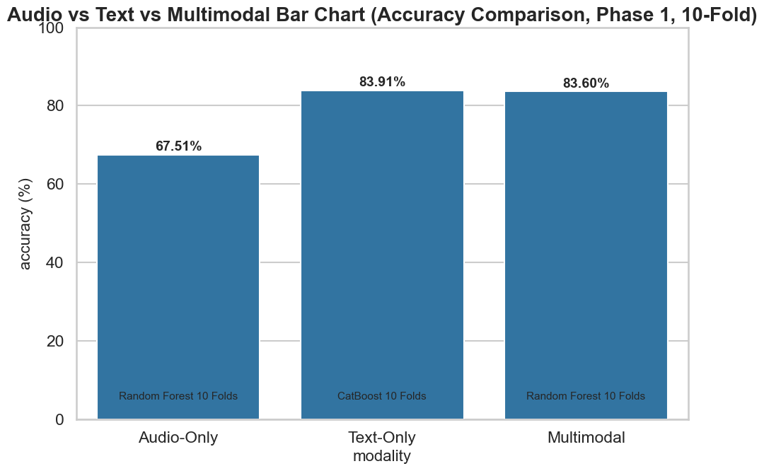
Figure 4.2. Best Phase 1 accuracy by modality (audio, text, multimodal).

4.3.4 Non-phasewise pooled-session experiments
The pooled per-participant features (without phase column) were used for complementary experiments on the following text, audio and multimodal features, each having 141 samples.The following text, audio and multimodal features were used in complementary experiments on pooled per-participant features (excluding phase column). The accuracy of the held-out test sets was close to 83.7% on the text and 0.866 on the ROC-AUC scores, while the accuracy was weaker for the audio-only test sets (near 0.44 on single split, ~0.63 under five-fold CV) using the Random Forest five-fold cross-validation approach. The overall accuracy rate for multimodal was about 70.9% ± 1.5% (averaged over the 5 folds).
These runs are meant to demonstrate that phase-wise granularity impacts absolute numbers and should not be taken at face value when comparing to pooled-session numbers unless the sessions are harmonised by phase. In non-phasewise notebooks, the models used are: Random Forest, XGBoost, and SVM, with a comparable but limited benchmark for the six models before the expanded study in phasewise notebooks. The pooled pipeline demonstrates that by excluding temporal segmentation, learnable signal arises in text and multimodal domains from the preprocessed data and from the labels.
4.4 Phase-wise Experimental Results
Table 4.3. Phase-wise multimodal results (Random Forest and best overall).
Phase | Best multimodal accuracy (%) | RF accuracy (%) | RF F1
Phase 1 (early) | 83.89 | 83.89 | 0.6957
Phase 2 (middle) | 82.22 | 82.22 | 0.6364
Phase 3 (late) | 77.85 | 63.33 | 0.3529

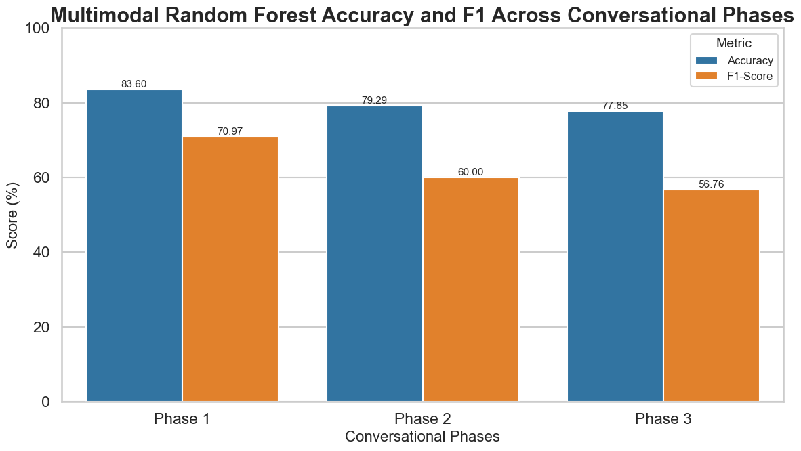
Figure 4.3. Multimodal Random Forest accuracy and F1 across conversational phases.
4.5 Comparative Performance Analysis
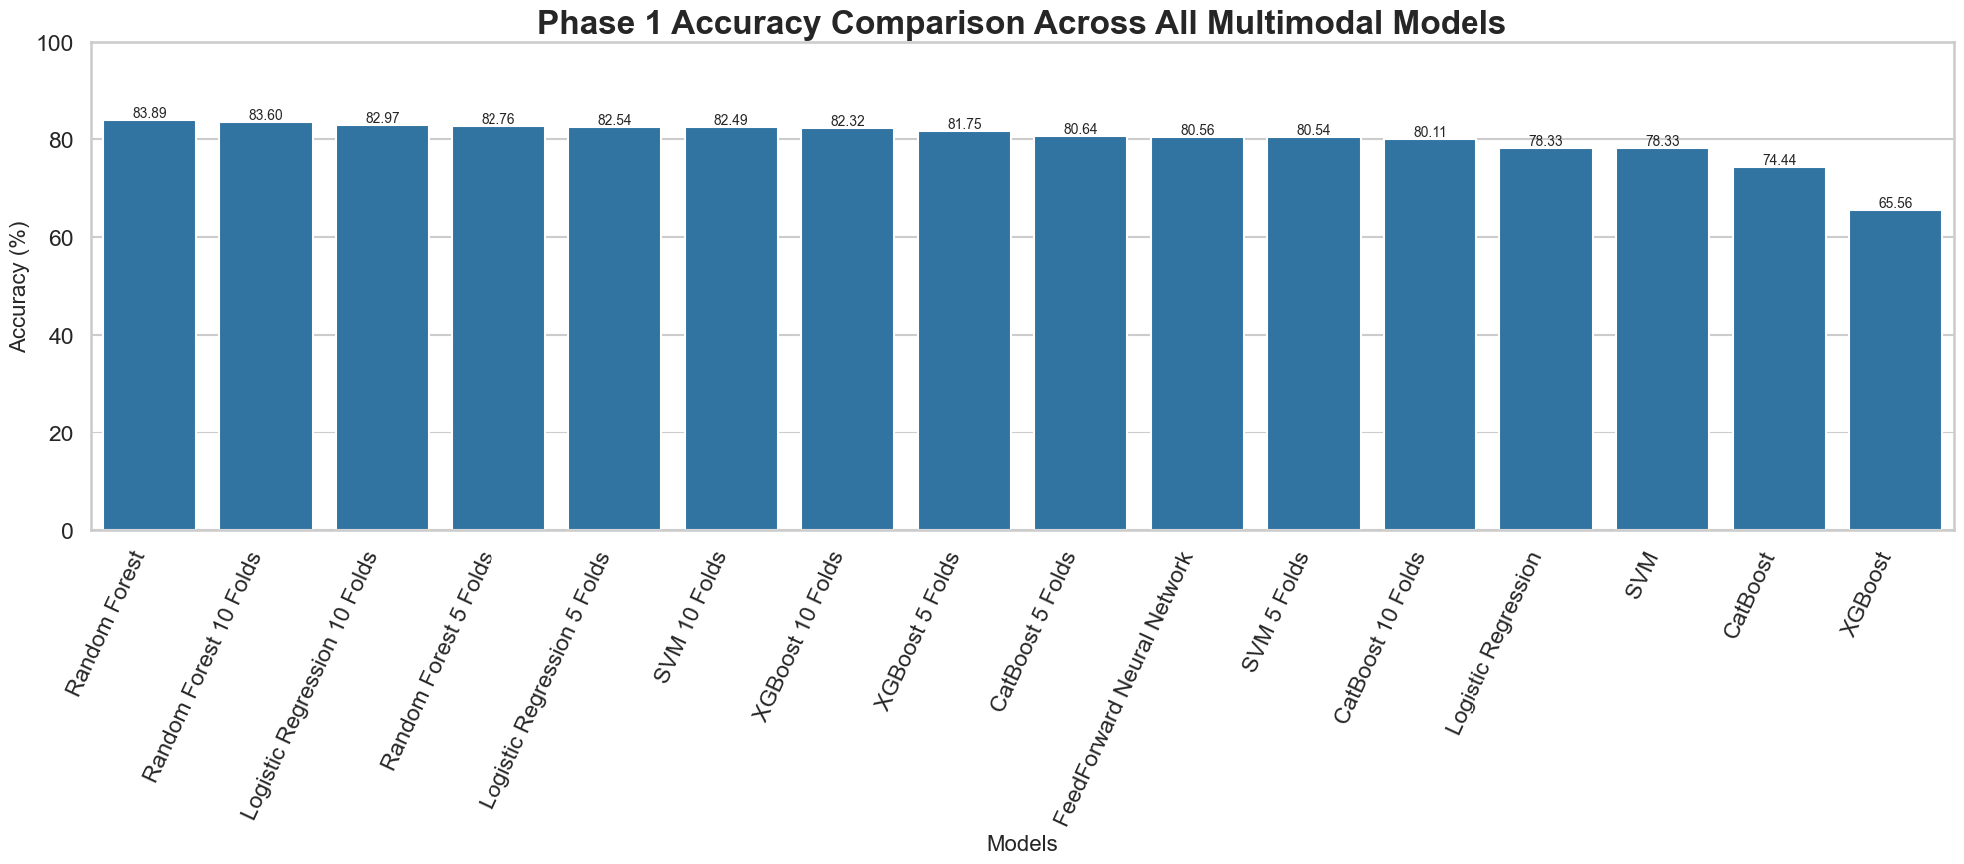
Figure 4.4. Phase 1 accuracy comparison across all multimodal models.
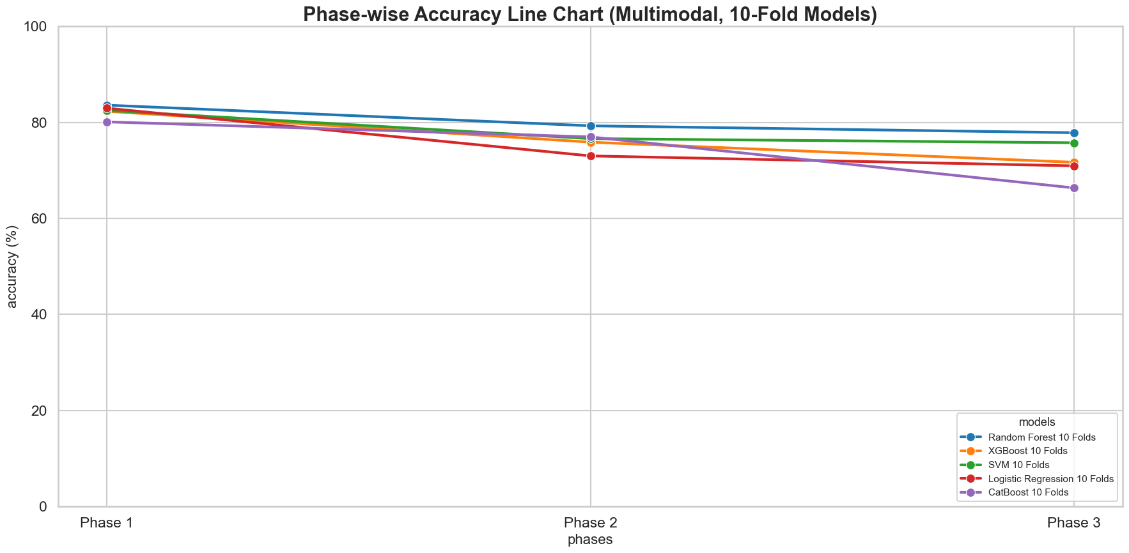
Figure 4.5. Phase-wise accuracy trends for all classifiers under multimodal 10-fold cross-validation, illustrating progressive performance decline across conversational phases.

4.6 Feature Importance Analysis
For the best tree-based multimodal model (Random Forest) the most important features in feature group importance are SBERT embeddings, MFCC/prosodic descriptors and energy-related features.
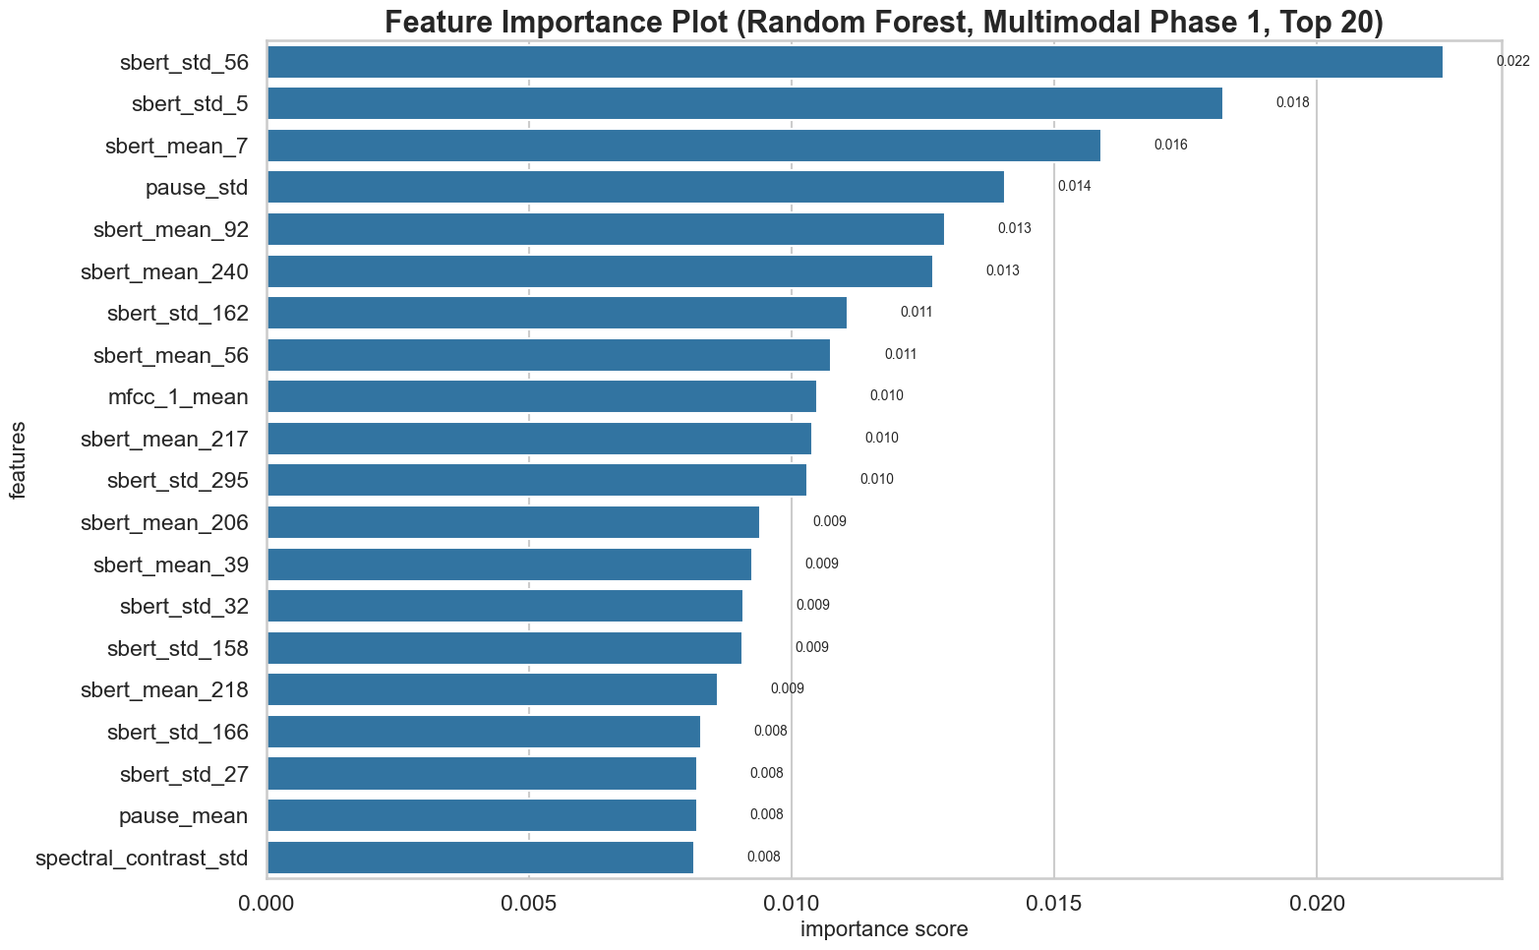
Figure 4.6. Relative feature-group importance (multimodal Random Forest, Phase1).

4.7 Confusion Matrix Analysis
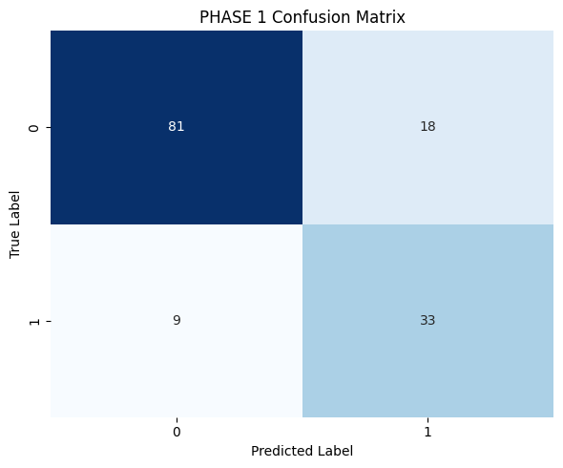
Figure 4.7. Confusion matrix for the best overall model (multimodal Random Forest). Diagonal dominance indicates correct classification; off-diagonal mass reflects false negatives among depressed participants under imbalance.

4.8 Observations and Discussions
When the meaning of what is said and how it is said is consistent, then multimodal fusion is more robust in early phases of the interview. The accuracy of text-only models is higher in the raw, indicating that there is more lexical-semantic signal in this corpus; in Phase 1, the multimodal RF is more balanced in terms of precision and recall. The level of performance is usually reduced in Phase 3, reflecting greater variability, as the interview touches on sensitive issues and/or participants become fatigued. It is essential to use a pre-processing step to remove the speech of the interviewer or else non-participant acoustic patterns would be introduced. The 0.40 probability cutoff value is a compromise that balances overall accuracy with clinical utility of recalling depressed cases.
4.9 Advantages and Limitations
Benefits: repeatable pipeline, wide model comparison, phase-sensitive analysis and features interpretable to the user. Limitations: a small sample size, a corpus domain limited to a single corpus, a heuristic in the tertile phase split, no external validation corpus and an illustrative feature-importance aggregation instead of a per-fold SHAP analysis.
In audio-only experiments, cross-validated random forest models outperform single-split XGBoost models occasionally, suggesting variation in the composition of the folds. Acoustic depression cues are weak or non-stationary over the course of the interview in several models in this corpus, as illustrated in the audio accuracy in both Phase 2 and Phase 3.
If the SBERT dimensions are much more numerous than the number of columns, it is recommended to use CatBoost, which supports ordered boosting and natively supports heterogeneous feature scales. A high recall (0.95) at Phase 1, coupled with a low precision (0.35), shows the downside of aggressively thresholding: many participants who do not have depressed trees are called, but with no corresponding increase in balanced accuracy.
Multimodal random forest (700 estimators, max_depth 12, balanced class weights) was specially tuned on fused vectors. The low F1 score of about 0.70 in Phase 1 indicates a good balance for use cases that are screening-oriented where false negatives are more costly than false positives. Phase 3 F1 is at about 0.35 on hold-out data, and a warning to use it without recalibration.
The results of logistic regression with 10-fold CV are competitive in terms of Phase 1 accuracy (82.97%). This proves that after scaling much of the fused signal can be linearly separated. This discovery implies that future studies may focus on regularised linear models over complex ensembles in the case of interpretability.
When the modalities are compared at their peak, text leads and multimodal follows closely and audio trails. In Phase 2 the gap between text and multimodal becomes more similar, suggesting that acoustic features might be more stable in the mid-interview if semantic content is still discriminative. SBERT embedding blocks are most highly featured, and next take the place of MFCC means and pause-derived text statistics in the feature-importance summaries.
5. CONCLUSION AND FUTURE WORK
To be able to process the data, the preprocessing step, followed by the phase-wise feature extraction, the multimodal fusion, and the comparative evaluation of the machine learning models, was taken into consideration. The study showed that the best performance was obtained by the Text model, with CatBoost achieving an accuracy of 85.56% in the first phase and the multimodal Random Forest model an accuracy of 83.89% and an F1 score of 0.70. The audio-only models, on the other hand, reached a maximum accuracy of around 67.62%, suggesting that linguistic representations contained more predictive information than the acoustic features in the test set used. The experiments also illustrated the fact that the later stages of conversations tended to be more challenging for the multimodal models, indicating that depression-related information may be easier to identify in the initial portion of an interview. Project contributions included an integrated framework of preprocessing scripts, phase-wise datasets and systematic benchmarking using common validation and thresholding approaches, providing a fair comparison between different models and modalities. However, there are a number of limitations, such as small sample size and class imbalance, no clinician-in-the-loop validation, and offline batch processing, rather than real-time inference. Transformer-based end-to-end approaches like wav2vec2 or HuBERT, fine-tuned with participant-only audio, could be explored in future work to go beyond the conventional MFCC representations. Likewise, there exist specialised text encoders, e.g., depression-specific RoBERTa models, which could benefit more from the use of larger labelled datasets. A more sophisticated multimodal transformer with cross-attention fusion could further enhance the contextual modelling ability, but was not explored in this undergraduate project due to the limitation of computational cost and training data. If the test set is extended to the entire DAIC set, the statistics will be more reliable and a speaker-independent evaluation can be done with demographic-aware group k-fold validation. External validation on other datasets like E-DAIC or AVEC challenge benchmarks would also be useful to provide more evidence for generalisability. Furthermore, future real-time systems can process streaming audio incrementally, keep the causal transcript alignment and update conversational phase buffers on the fly, although keeping the latency below 500 ms is still difficult without model distillation with transformer-based text encoders. Lastly, techniques like explainability for tree-based models (SHAP) and for neural networks (Integrated Gradients) should be included in any future clinical deployment to enhance interpretability and trust, and regulatory aspects of Software as a Medical Device (SaMD) should be mandatory for the integration of different types of software in the healthcare domain.
6. REFERENCES
[1] A. Gratch et al., "The Distress Analysis Interview Corpus of human and computer interviews," in Proc. LREC, 2014.
[2] T. Ma et al., "Audio-based prediction of depression severity using deep learning," Proc. Interspeech, 2016.
[3] N. Cummins et al., "A review of depression and suicide risk assessment using speech analysis," Speech Commun., vol. 71, pp. 10–49, 2015.
[4] M. Valstar et al., "AVEC 2016: Depression, mood, and emotion recognition workshop," in Proc. ACM MM, 2016.
[5] J. Devlin et al., "BERT: Pre-training of deep bidirectional transformers," NAACL, 2019.
[6] N. Reimers and I. Gurevych, "Sentence-BERT: Sentence embeddings using siamese BERT-networks," EMNLP, 2019.
[7] F. Pedregosa et al., "Scikit-learn: Machine learning in Python," JMLR, vol. 12, pp. 2825–2830, 2011.

7. APPENDICES
Appendix A — Complete phasewise score tables
Table A.1. Text-only — Phase 1 results (all models).
Model | Phase 1
 | Accuracy | Precision | Recall | F1-Score
Random Forest | 60.83% | 1 | 0.11 | 0.2
Random Forest 5 Folds | 71.43% | 0.5714 | 0.1905 | 0.2857
Random Forest 10 Folds | 74.54% | 0.6667 | 0.1905 | 0.2963
XGBoost | 73.89% | 0.4286 | 0.3333 | 0.375
XGBoost 5 Folds | 64.96% | 0.3774 | 0.4762 | 0.4211
XGBoost 10 Folds | 68.59% | 0.4528 | 0.5714 | 0.5053
SVM | 51.11% | 0.32 | 0.8889 | 0.4706
SVM 5 Folds | 58.42% | 0.5333 | 0.1905 | 0.2807
SVM 10 Folds | 54.35% | 0.3143 | 0.2619 | 0.2857
Logistic Regression | 55.56% | 0.2857 | 0.6667 | 0.4
Logistic Regression 5 Folds | 58.90% | 0.3084 | 0.7857 | 0.443
Logistic Regression 10 Folds | 61.78% | 0.3241 | 0.8333 | 0.4667
CatBoost | 85.56% | 0.7 | 0.7778 | 0.7368
CatBoost 5 Folds | 81.07% | 0.62 | 0.7381 | 0.6739
CatBoost 10 Folds | 83.91% | 0.6458 | 0.7381 | 0.6889
FeedForward Neural Network | 80.01% | 0.3509 | 0.9524 | 0.5128

Table A.2. Text-only — Phase 2 results (all models).
Model | Phase 2
 | Accuracy | Precision | Recall | F1-Score
Random Forest | 71.39 | 1 | 0.11 | 0.2
Random Forest 5 Folds | 68.42 | 0.8333 | 0.2381 | 0.3704
Random Forest 10 Folds | 69.85% | 1 | 0.2619 | 0.4151
XGBoost | 58.33% | 0.4 | 0.4444 | 0.4211
XGBoost 5 Folds | 63.01% | 0.4348 | 0.4762 | 0.4545
XGBoost 10 Folds | 0.6494 | 0.44 | 0.5238 | 0.4783
SVM | 41.67% | 0.3103 | 1 | 0.4737
SVM 5 Folds | 48.05% | 0.2667 | 0.0952 | 0.1404
SVM 10 Folds | 43.75% | 0.2 | 0.0476 | 0.0769
Logistic Regression | 45% | 0.3077 | 0.8889 | 0.4571
Logistic Regression 5 Folds | 50.05% | 0.2963 | 0.9524 | 0.452
Logistic Regression 10 Folds | 48.80% | 0.2963 | 0.9524 | 0.452
CatBoost | 72.22% | 0.4444 | 0.4444 | 0.4444
CatBoost 5 Folds | 75.04% | 0.5455 | 0.5714 | 0.5581
CatBoost 10 Folds | 78.60% | 0.5682 | 0.5952 | 0.5814
FeedForward Neural Network | 75.06% | 0.3171 | 0.9286 | 0.4727

Table A.3. Text-only — Phase 3 results (all models).
Model | Phase 3
 | Accuracy | Precision | Recall | F1-Score
Random Forest | 53.06% | 1 | 0.11 | 0.2
Random Forest 5 Folds | 61.32% | 0.6 | 0.0714 | 0.1277
Random Forest 10 Folds | 57.71% | 1 | 0.0476 | 0.0909
XGBoost | 52.78% | 0.2667 | 0.4444 | 0.3333
XGBoost 5 Folds | 60.41% | 0.35 | 0.5 | 0.4118
XGBoost 10 Folds | 60.85% | 0.32 | 0.381 | 0.3478
SVM | 54.44% | 0.3043 | 0.7778 | 0.4375
SVM 5 Folds | 48.10% | 0.1429 | 0.0714 | 0.0952
SVM 10 Folds | 51.13% | 0.3077 | 0.1905 | 0.2353
Logistic Regression | 43.89% | 0.3333 | 1 | 0.5
Logistic Regression 5 Folds | 46.15% | 0.2955 | 0.9286 | 0.4483
Logistic Regression 10 Folds | 46.49% | 0.3015 | 0.9762 | 0.4607
CatBoost | 71.11% | 0.6667 | 0.6667 | 0.6667
CatBoost 5 Folds | 67.20% | 0.4565 | 0.5 | 0.4773
CatBoost 10 Folds | 65.15% | 0.475 | 0.4524 | 0.4634
FeedForward Neural Network | 74.29% | 0.3203 | 0.9762 | 0.4824

Table A.4. Audio-only — Phase 1 results (all models).
Model | Phase 1
 | Accuracy | Precision | Recall | F1-Score
Random Forest | 60.28% | 0.2857 | 0.2222 | 0.25
Random Forest 5 Folds | 67.62% | 0.5185 | 0.3333 | 0.4058
Random Forest 10 Folds | 67.51% | 0.52 | 0.3095 | 0.3881
XGBoost | 51.11% | 0.3529 | 0.6667 | 0.4615
XGBoost 5 Folds | 66.81% | 0.3922 | 0.4762 | 0.4301
XGBoost 10 Folds | 66.31% | 0.3774 | 0.4762 | 0.4211
SVM | 54.44% | 0.25 | 0.1111 | 0.1538
SVM 5 Folds | 67.00% | 0.6 | 0.0714 | 0.1277
SVM 10 Folds | 61.50% | 0.4286 | 0.0714 | 0.1224
Logistic Regression | 53.33% | 0.3125 | 0.5556 | 0.4
Logistic Regression 5 Folds | 63.56% | 0.3537 | 0.6905 | 0.4677
Logistic Regression 10 Folds | 60.65% | 0.359 | 0.6667 | 0.4667
CatBoost | 50.56% | 0.3571 | 0.5556 | 0.4348
CatBoost 5 Folds | 63.20% | 0.4118 | 0.5 | 0.4516
CatBoost 10 Folds | 63.23% | 0.4375 | 0.5 | 0.4667
FeedForward Neural Network | 52.22% | 0.3478 | 0.8889 | 0.5

Table A.5. Audio-only — Phase 2 results (all models).
Model | Phase 2
 | Accuracy | Precision | Recall | F1-Score
Random Forest | 45.56% | 0.375 | 0.3333 | 0.3529
Random Forest 5 Folds | 60.98% | 0.4516 | 0.3333 | 0.3836
Random Forest 10 Folds | 60.37% | 0.5 | 0.3571 | 0.4167
XGBoost | 40.56% | 0.2353 | 0.4444 | 0.3077
XGBoost 5 Folds | 55.53% | 0.3137 | 0.381 | 0.3441
XGBoost 10 Folds | 55.68% | 0.3396 | 0.4286 | 0.3789
SVM | 46.11% | 0.25 | 0.1111 | 0.1538
SVM 5 Folds | 58.30% | 0.5 | 0.0238 | 0.0455
SVM 10 Folds | 58.99% | 0.5 | 0.0238 | 0.0455
Logistic Regression | 54.44% | 0.2667 | 0.4444 | 0.3333
Logistic Regression 5 Folds | 59.26% | 0.3467 | 0.619 | 0.4444
Logistic Regression 10 Folds | 60.25% | 0.3412 | 0.6905 | 0.4567
CatBoost | 45.56% | 0.2857 | 0.4444 | 0.3478
CatBoost 5 Folds | 60.13% | 0.6013 | 0.4762 | 0.4211
CatBoost 10 Folds | 60.61% | 0.4038 | 0.5 | 0.4468
FeedForward Neural Network | 47.78% | 0.3333 | 1 | 0.5

Table A.6. Audio-only — Phase 3 results (all models).
Model | Phase 3
 | Accuracy | Precision | Recall | F1-Score
Random Forest | 43.33% | 0.4 | 0.2222 | 0.2857
Random Forest 5 Folds | 63.38% | 0.4516 | 0.3333 | 0.3836
Random Forest 10 Folds | 61.84% | 0.4483 | 0.3095 | 0.3662
XGBoost | 42.78% | 0.2143 | 0.3333 | 0.2609
XGBoost 5 Folds | 58.20% | 0.3922 | 0.4762 | 0.4301
XGBoost 10 Folds | 61.16% | 0.4314 | 0.5238 | 0.4731
SVM | 42.22% | 0.25 | 0.1111 | 0.1538
SVM 5 Folds | 62.17% | 0.5 | 0.0238 | 0.0455
SVM 10 Folds | 53.27% | 0.5 | 0.0238 | 0.0455
Logistic Regression | 42.78% | 0.2308 | 0.3333 | 0.2727
Logistic Regression 5 Folds | 60.61% | 0.3556 | 0.7619 | 0.4848
Logistic Regression 10 Folds | 59.36% | 0.3409 | 0.7143 | 0.4615
CatBoost | 38.33% | 0.2222 | 0.2222 | 0.2222
CatBoost 5 Folds | 58.47% | 0.4314 | 0.5238 | 0.4731
CatBoost 10 Folds | 61.30% | 0.4565 | 0.5 | 0.4773
FeedForward Neural Network | 46.11% | 0.2692 | 0.7778 | 0.4

Table A.7. Multimodal — Phase 1 results (all models).
Model | Phase 1
 | Accuracy | Precision | Recall | F1-Score
Random Forest | 83.89% | 0.5714 | 0.8889 | 0.6957
Random Forest 5 Folds | 82.76% | 0.5882 | 0.7143 | 0.6452
Random Forest 10 Folds | 83.60% | 0.6471 | 0.7857 | 0.7097
XGBoost | 65.56% | 0.4615 | 0.6667 | 0.5455
XGBoost 5 Folds | 81.75% | 0.5538 | 0.8571 | 0.6729
XGBoost 10 Folds | 82.32% | 0.5556 | 0.8333 | 0.6667
SVM | 78.33% | 0.5 | 0.5556 | 0.5263
SVM 5 Folds | 80.54% | 0.5909 | 0.619 | 0.6047
SVM 10 Folds | 82.49% | 0.617 | 0.6905 | 0.6517
Logistic Regression | 78.33% | 0.5833 | 0.7778 | 0.6667
Logistic Regression 5 Folds | 82.54% | 0.5741 | 0.7381 | 0.6458
Logistic Regression 10 Folds | 82.97% | 0.625 | 0.7143 | 0.6667
CatBoost | 74.44% | 0.5 | 0.8889 | 0.64
CatBoost 5 Folds | 80.64% | 0.6 | 0.7857 | 0.6804
CatBoost 10 Folds | 80.11% | 0.5536 | 0.7381 | 0.6327
FeedForward Neural Network | 80.56% | 0.3913 | 1 | 0.5625

Table A.8. Multimodal — Phase 2 results (all models).
Model | Phase 2
 | Accuracy | Precision | Recall | F1-Score
Random Forest | 82.22% | 0.5385 | 0.7778 | 0.6364
Random Forest 5 Folds | 78.43% | 0.6486 | 0.5714 | 0.6076
Random Forest 10 Folds | 79.29% | 0.6316 | 0.5714 | 0.6
XGBoost | 63.33% | 0.5 | 0.5556 | 0.5263
XGBoost 5 Folds | 74.96% | 0.4909 | 0.6429 | 0.5567
XGBoost 10 Folds | 75.88% | 0.4808 | 0.5952 | 0.5319
SVM | 77.22% | 0.5556 | 0.5556 | 0.5556
SVM 5 Folds | 76.48% | 0.5532 | 0.619 | 0.5843
SVM 10 Folds | 76.62% | 0.5208 | 0.5952 | 0.5952
Logistic Regression | 67.22% | 0.4444 | 0.4444 | 0.4444
Logistic Regression 5 Folds | 73.79% | 0.5435 | 0.5952 | 0.5682
Logistic Regression 10 Folds | 73.02% | 0.5 | 0.619 | 0.5532
CatBoost | 76.67% | 0.5 | 0.5556 | 0.5263
CatBoost 5 Folds | 75.73% | 0.549 | 0.6667 | 0.6022
CatBoost 10 Folds | 76.98% | 0.551 | 0.6429 | 0.5934
FeedForward Neural Network | 75.00% | 0.2917 | 0.7778 | 0.4242

Table A.9. Multimodal — Phase 3 results (all models).
Model | Phase 3
 | Accuracy | Precision | Recall | F1-Score
Random Forest | 63.33% | 0.375 | 0.3333 | 0.3529
Random Forest 5 Folds | 74.43% | 0.5758 | 0.4524 | 0.5067
Random Forest 10 Folds | 77.85% | 0.6562 | 0.5 | 0.5676
XGBoost | 52.78% | 0.3333 | 0.3333 | 0.3333
XGBoost 5 Folds | 70.37% | 0.4143 | 0.6905 | 0.5179
XGBoost 10 Folds | 71.69% | 0.4516 | 0.6667 | 0.5385
SVM | 69.44% | 0.5556 | 0.5556 | 0.5556
SVM 5 Folds | 73.98% | 0.5306 | 0.619 | 0.5714
SVM 10 Folds | 75.76% | 0.5778 | 0.619 | 0.5977
Logistic Regression | 57.22% | 0.3636 | 0.4444 | 0.4
Logistic Regression 5 Folds | 69.41% | 0.449 | 0.5238 | 0.4835
Logistic Regression 10 Folds | 70.95% | 0.4902 | 0.5952 | 0.5376
CatBoost | 48.89% | 0.3333 | 0.3333 | 0.3333
CatBoost 5 Folds | 63.20% | 0.3966 | 0.5476 | 0.46
CatBoost 10 Folds | 66.35% | 0.4694 | 0.5476 | 0.5055
FeedForward Neural Network | 69.44% | 0.3103 | 1 | 0.4737

8. REFLECTION OF TEAM MEMBERS
Debi Prasad Nanda
This project gave me lots of practical experience in designing a whole research process for multimodal depression detection. Planned the overall project pipeline, designed the conversational segmentation strategy for phases, feature extraction processes, and analyzed the experimental results. Acquired skills in extracting behavioural information from conversational audio and textual data for mental health analysis. One of the best things about our design process was that we were able to compare the experiments in a systematic way and had a structured workflow. One of the difficulties we encountered were the number of stages in the preprocessing, feature extraction and evaluation and how to maintain consistency throughout all of the experiments.
Chandna Nayak
This project has enabled me to gain a solid knowledge of literature survey techniques and text-based behaviour analysis. I conducted research primarily on reading existing research papers, extracting linguistic features from the transcriptions, and helping in documentation. I became familiar with the patterns in texts and conversation in relation to depression detection systems. This was one of the strengths of our team because we were able to work together in the research and documentation process. One difficulty was comprehending and structuring vast amounts of research information, and keeping technical writing consistent.
Prabyasachi Mohanty
This project further deepened my hands-on experience in the field of machine learning application and experiments. Primarily concentrated on conducting coding, modelling, training, testing and performance evaluation. I learned the various types of machine learning algorithms in behavioural data and comparative experiments on different algorithms to get a better idea of what algorithm is a proper match to classify a behavioural dataset. The comparative analysis of several machine learning models was something we had as one of our strengths for our project. One challenge was to optimize the model performance while assuring the proper evaluation and interpretation of model results.
Debasish Nanda
In this project, I was able to gain hands-on experience with preprocessing conversational audio data and preparing datasets to experiment with. Preprocess related tasks, and helped implement various stages of the project pipeline. Discovered the crucial role of clean and structured data to enhance machine learning results. The organized preprocessing strategy that was used prior to feature extraction and classification is one of the strengths of our workflow. One difficulty was dealing with conversational data that could be noisy, and ensuring consistency at the preprocessing stage.
Pushpaja Priyadarsini
This project enabled me to understand the importance of literature survey and preprocessing in ML projects that are research oriented. I worked primarily on research projects, pre-processing works and documentation of projects. Understood the importance of pre-processing and proper preparation of the dataset on the overall quality of experimental results. Good teamwork and coordination among the members of our project during research and documentation were one of the strengths of our project. A challenge was the balance of detailed technical explanations and concise academic writing.
9. SIMILARITY REPORT

